Юзкейс діаграма системи

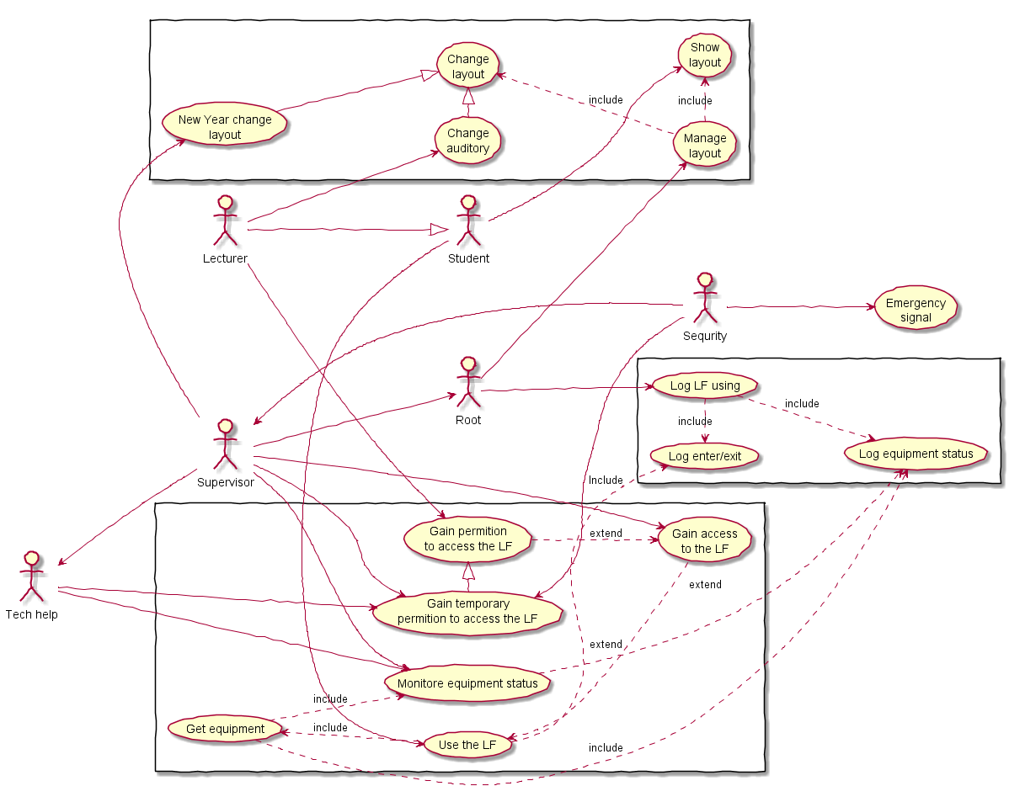

3.3.1

@startuml

actor User

User -> System : ShowGUI Async

activate System

User -> System : Show auditory

System --> User : Return auditory

destroy System

@enduml

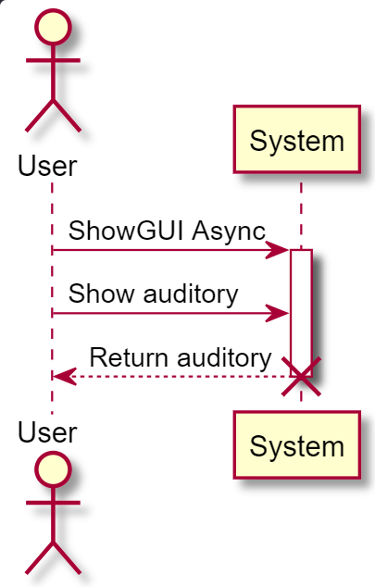

3.3.2

@startuml

actor User

User -> Supervisor : Change layout request

activate Supervisor

Supervisor -> User : Give form

User -> User : Fill form

User --> Supervisor : Return form

alt Request\nacceptable

Supervisor -> Root : Send changelog

activate Root

ref over Root : System::KeepChange();\nSystem::RefreshGUI();

Root --> Supervisor : Report success

destroy Root

Supervisor --> User : Report success

else Request\ninacceptable

Supervisor --> User : Request denied

end

destroy Supervisor

@enduml

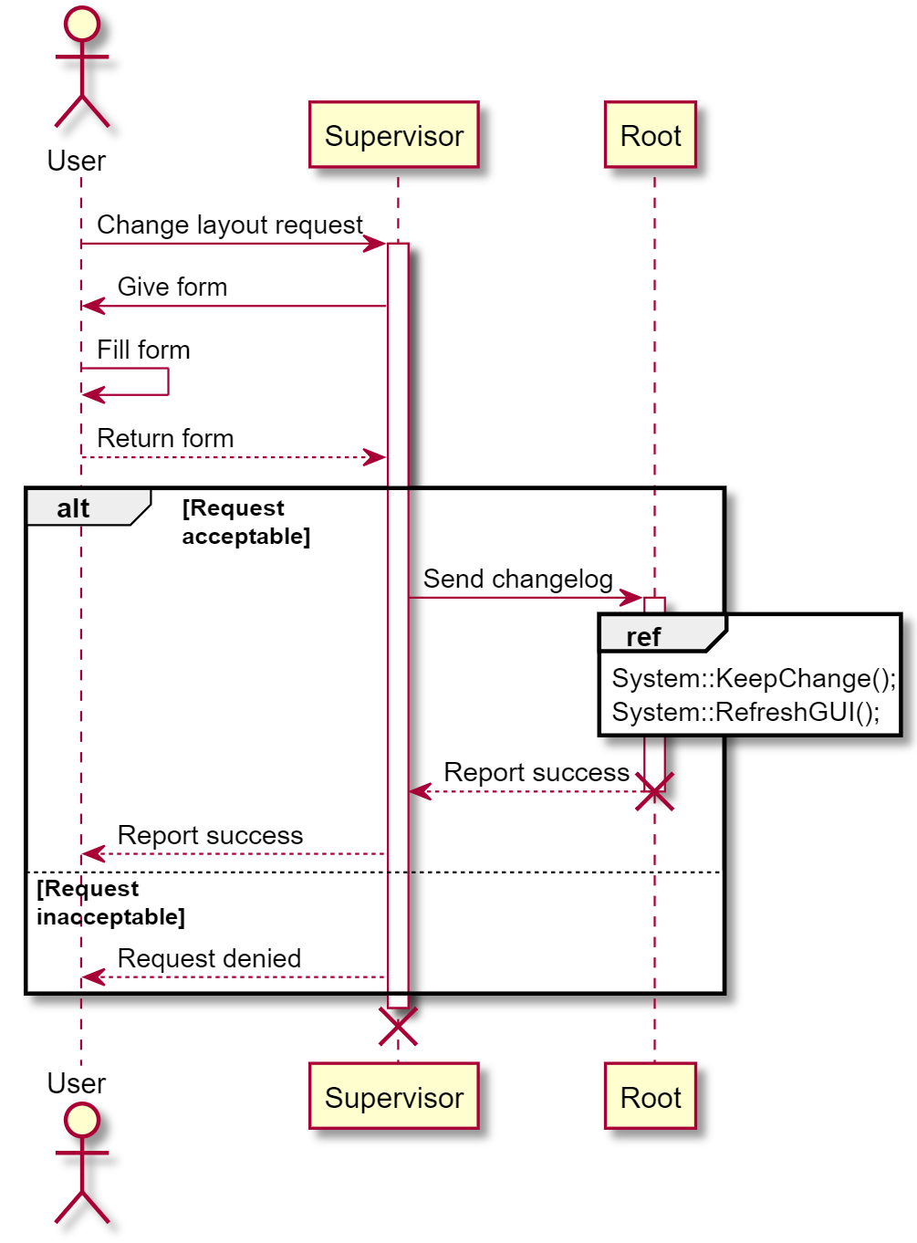

3.3.3

@startuml

actor Lecturer

Lecturer -> Supervisor : Give access request

activate Supervisor

Supervisor -> Lecturer : Give form

Lecturer -> Lecturer : Fill form

Lecturer --> Supervisor : Return form

ref over Supervisor : Create lecturer's UUID

Supervisor -> Root : Give access request

activate Root

ref over Root : System::AddLecturer();

Root --> Supervisor : Report success

destroy Root

Supervisor --> Lecturer : Report success\nGive UUID

destroy Supervisor

@enduml

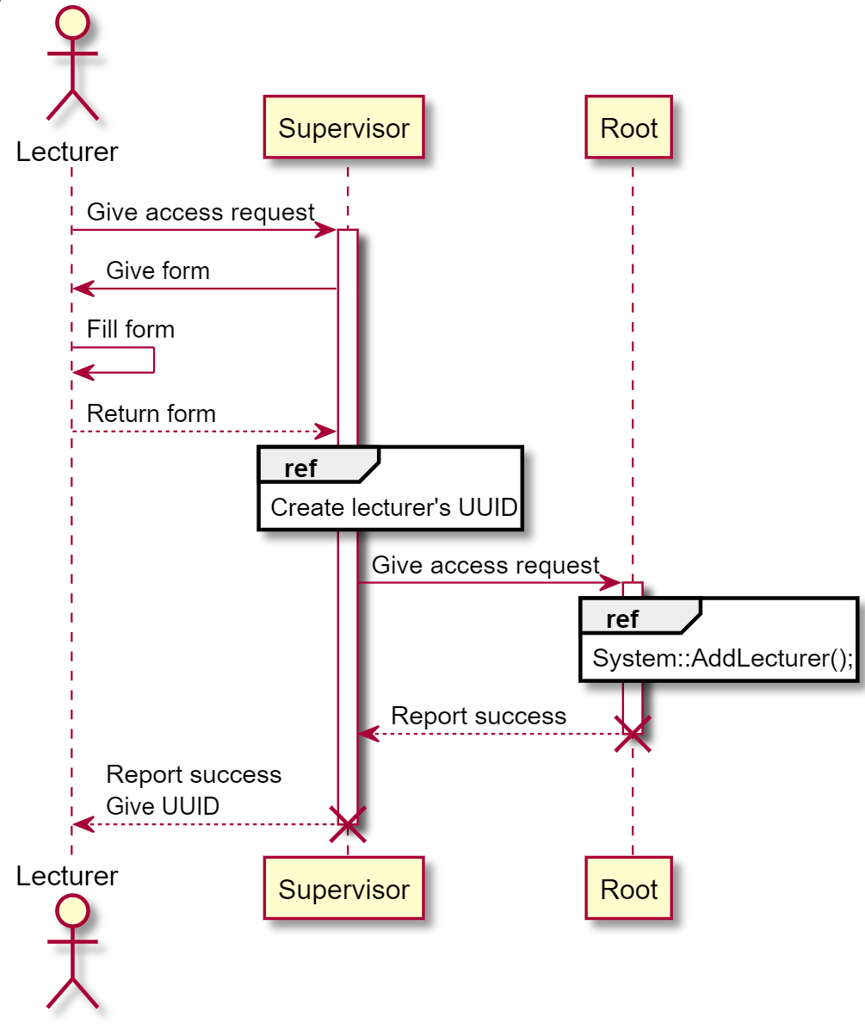

3.3.4

@startuml

actor Lecturer

Lecturer -> Supervisor : Change auditory request

activate Supervisor

alt Change acceptable

Supervisor -> Root : Change layout request

activate Root

ref over Root : System::DeleteLaws();\nSystem::GiveLaws();\nSystem::RefreshGUI();

Root --> Supervisor : Report success

destroy Root

Supervisor --> Lecturer : Report success

else Changes inacceptable

Supervisor --> Lecturer : Request denied

end

destroy Supervisor

@enduml

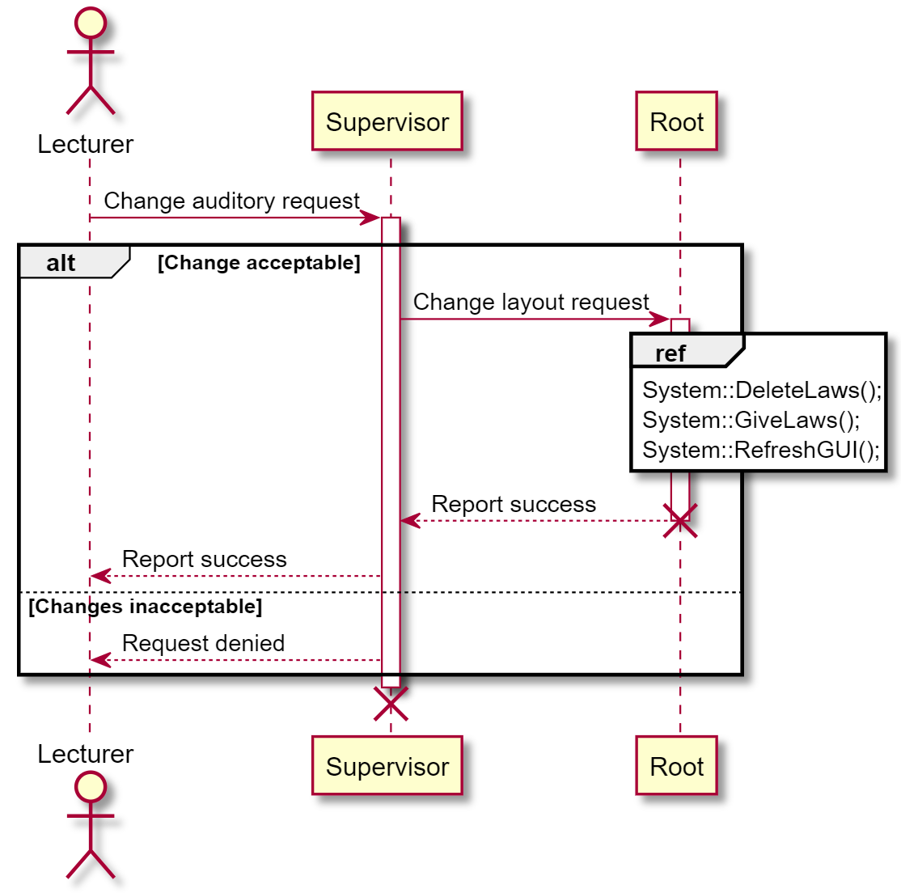

3.3.5

@startuml

actor Supervisor

ref over Supervisor : Create layout\nfor new year

Supervisor -> Root : Change layout request

ref over Root : System::KeepChanges();\nSystem::RefreshGUI();

Root --> Supervisor : Report success

@enduml

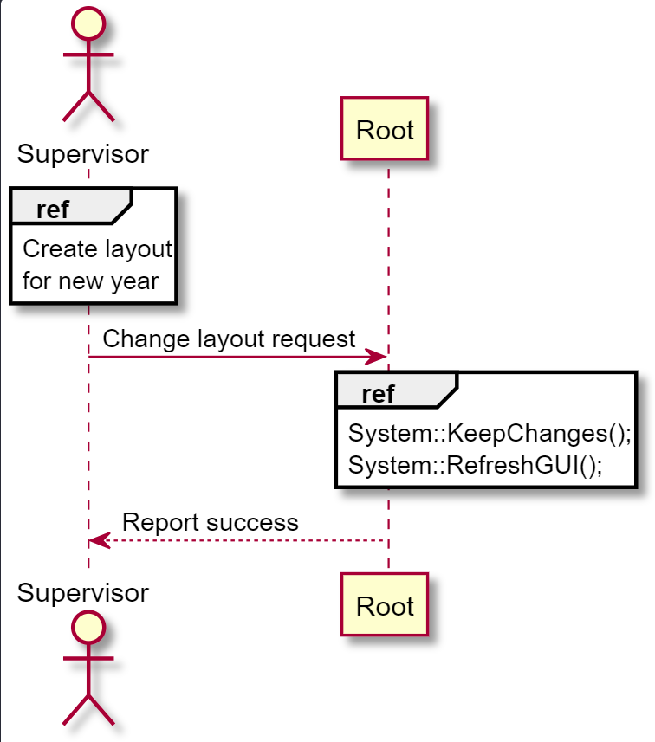

3.3.6

actor Lecturer  
Lecturer -> System : Authentication Request  
activate System  
activate System [#ffaa00](tg://search_hashtag?hashtag=ffaa00)  
System -> DataBase : Verify lecturer  
alt Permition denied  
activate DataBase  
activate DataBase [#ffaa00](tg://search_hashtag?hashtag=ffaa00)  
DataBase --> System : Return fail flag  
destroy DataBase  
System --> Lecturer : Decline  
destroy System   
end  
DataBase -> System : Return success flag  
System --> Lecturer : Signal enter  
ref over System : System::OpenMaglock();  
System -> DataBase : Log lecture start Async  
ref over DataBase : Logging::LogEnter();\nLogging::LogLecturer();  
Lecturer -> Lecturer : Make lecture  
Lecturer -> System : Lecture over  
System -> Lecturer : Autentification Request  
Lecturer --> System : Verify  
alt Vetify success  
DataBase --> System : Return success flag  
System -> DataBase : Log lecture over Async  
ref over DataBase : Logging::LogExit();\nLogging::LogLecturer();  
System --> Lecturer : Signal Exit  
ref over System : System::CloseMaglock();  
else Permition denied  
DataBase --> System : Return fail flag  
System --> Lecturer : Decline  
end  
destroy DataBase  
destroy System

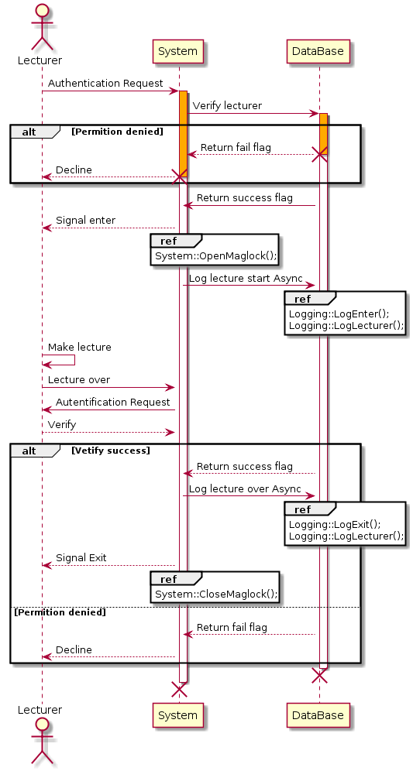

3.3.7

@startuml

actor "Superviseing member"

participant Supervisor

participant Administrator

participant System

"Superviseing member" -> Supervisor: request

activate Supervisor

Supervisor -> "Superviseing member": Authentification request

"Superviseing member" --> Supervisor: verify

alt successful case

Supervisor -> Administrator: card request

activate Administrator

Administrator -> "Superviseing member": Authentification request

"Superviseing member" --> Administrator: verify

alt successful case

Administrator -> "Superviseing member": give card

else verify failed

Administrator -> "Superviseing member": verifying failed

deactivate Administrator

end

else verify failed

Supervisor -> "Superviseing member": verifying failed

deactivate Supervisor

end

"Superviseing member" -> System: door opening request

activate System

System -> "Superviseing member": Authentification request

"Superviseing member" --> System: verify

alt successful case

ref over System : System::logEnter();

System -> "Superviseing member": give access

ref over System :logEquipment;

else verifying falied

System -> "Superviseing member": verifying failed

end

"Superviseing member" -> System: door closing request

System -> "Superviseing member": Authentification request

"Superviseing member" --> System: verify

alt successful case

ref over System : System::logExit();

System -> "Superviseing member": give access

else verifying failed

System -> "Superviseing member": verifying faliled

deactivate System

end

@enduml

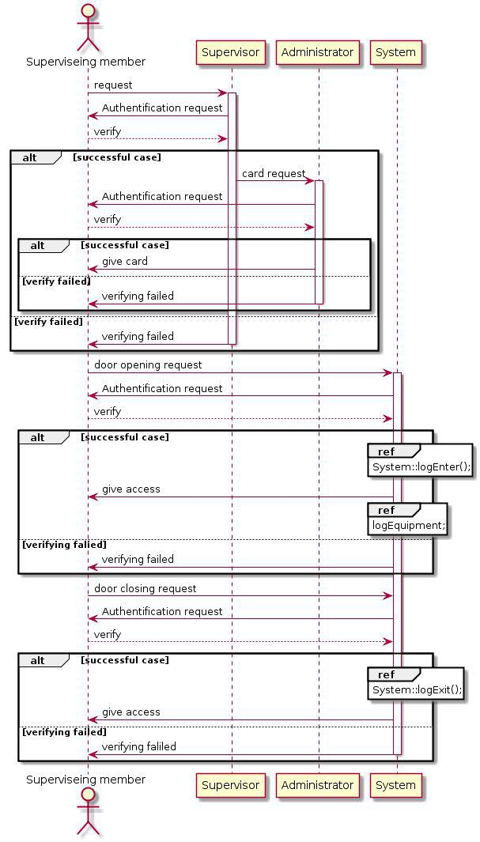

3.3.8

@startuml

actor Supervisor

Supervisor -> Supervisor : define auditorium/time

Supervisor -> Logging_System : request place/time

activate Logging_System

alt Place/time available

Logging_System --> Supervisor : requestCreated

Logging_System -> Tech_Help : place/time to receive tools

activate Tech_Help

Logging_System -> Security : place/time to receive tools

activate Security

ref over Tech_Help : Tech_Help::receive_tools()

Security -> Tech_Help : give access

Tech_Help --> Logging_System : tools received

destroy Tech_Help

Security --> Logging_System : access given

destroy Security

ref over Logging_System: System::log_tools_access()

else

Logging_System --> Supervisor : place/time not available

destroy Logging_System

end

@enduml

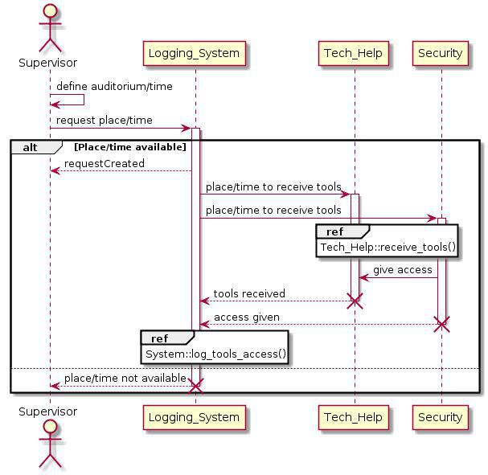

3.3.9

actor Teacher

actor Supervision

participant System

participant Physical_medium

ref over System

System::data_tools()

end ref

ref over Physical_medium

System::data_storage_tools()

end ref

Teacher -> Supervision: class request

activate Supervision

alt successful case

Supervision --> Teacher: granting consent

else verify failed

Supervision --> Teacher: Authentication Failure

destroy Supervision

alt successful case

Teacher -> System:call the forms

activate System

System --> Teacher: Getting started with the user

else Authentication Failure

System --> Teacher: Getting started with the user

Teacher -> System: filling in the data

System -> Physical_medium: record informatoin

activate Physical_medium

Physical_medium --> System:signal about the end of work

destroy Physical_medium

System --> Teacher: message about successful result

Teacher -> System:session completion

end

end

destroy System

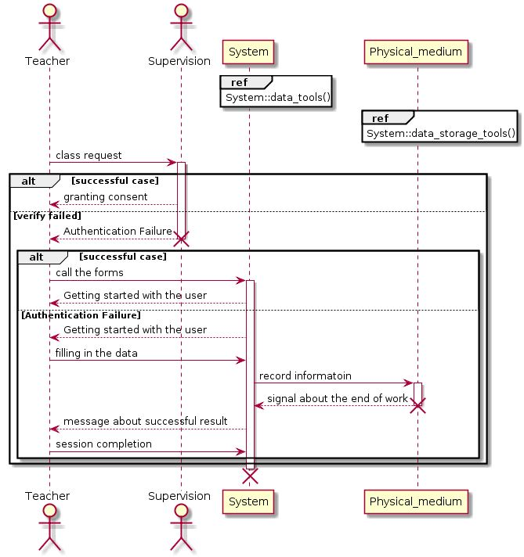

3.3.10

actor Student

Student -> Lecturer : Wait

Lecturer -> Lecturer : Comes

Lecturer -> System : Authentication Request

activate System

activate System #ffaa00

System -> DataBase : Verify lecturer

alt Permition denied

activate DataBase

activate DataBase #ffaa00

DataBase --> System : Return fail flag

destroy DataBase

System --> Lecturer : Decline

destroy System

end

DataBase -> System : Return success flag

System --> Lecturer : Signal enter

ref over System : System::OpenMaglock();

System -> DataBase : Log lecture start Async

ref over DataBase : Logging::LogEnter();\nLogging::LogLecturer();

Lecturer -> Student : Tell to come in

Student -> Student : Come in

Lecturer -> Lecturer : Make lecture

Lecturer -> System : Lecture over

Lecturer -> Student : Tell to come out

Student -> Student : Come out

System -> Lecturer : Autentification Request

Lecturer --> System : Verify

alt Vetify success

DataBase --> System : Return success flag

System -> DataBase : Log lecture over Async

ref over DataBase : Logging::LogExit();\nLogging::LogLecturer();

System --> Lecturer : Signal Exit

ref over System : System::CloseMaglock();

else Permition denied

DataBase --> System : Return fail flag

System --> Lecturer : Decline

end

destroy DataBase

destroy System

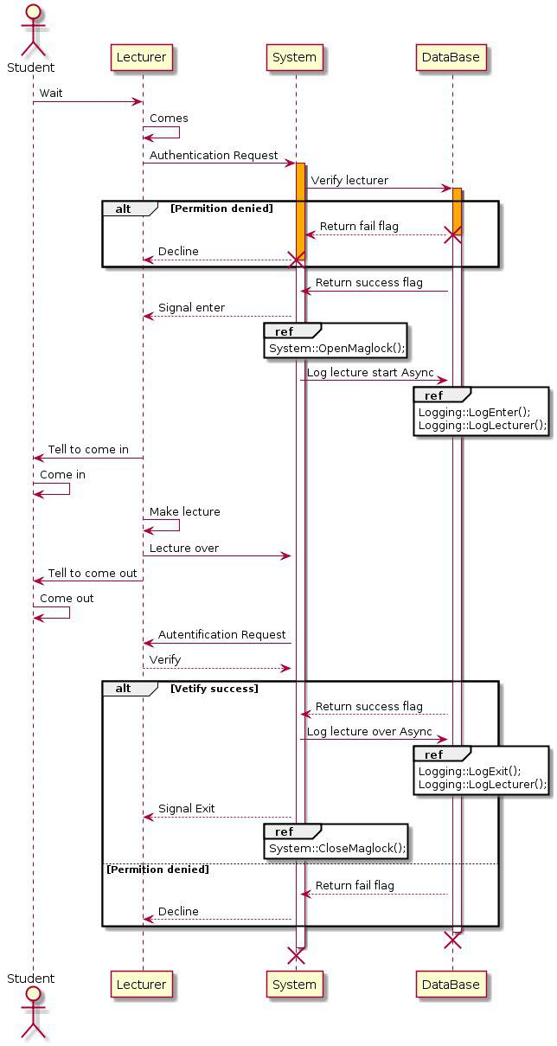

3.3.11

@startuml

actor Tech_Help

Tech_Help -> Logging_System : receive tools/get access to auditorium

activate Logging_System

alt permission received

Logging_System -> Security : ask to give tools

activate Security

Security --> Logging_System : tools available

Logging_System --> Tech_Help : access given

Security -> Tech_Help : give tools

ref over Tech_Help : Tech_Help::repair_university()

Tech_Help -> Logging_System : alarm about tools return

Logging_System -> Security : alarm about tools return

Security --> Logging_System : will arrive to return tools

Logging_System --> Tech_Help : guards will return the tools

Security -> Tech_Help : return tools to storage

else

Security --> Logging_System : tools unavailable

destroy Security

Logging_System --> Tech_Help : access denied

destroy Logging_System

end

Tech_Help -> Logging_System : check out tools condition

activate Logging_System

alt permission received

Logging_System -> Security : ask to give tools

activate Security

Security --> Logging_System : tools available

Logging_System --> Tech_Help : access given

Security -> Tech_Help : give tools

ref over Tech_Help : Tech_Help::check_out_condition()

Tech_Help -> Logging_System : alarm about tools condition

ref over Logging_System : Logging_System::write_into_LogFile()

alt tools condition\nis good

Logging_System -> Supervisor : send a LogFile

activate Supervisor

Supervisor --> Logging_System : have read a LogFile

destroy Supervisor

Logging_System -> Security : alarm about tools return

Security --> Logging_System : will arrive to return tools

Logging_System --> Tech_Help : guards will return the tools

Security -> Tech_Help : return tools to storage

else

ref over Logging_System : Logging_System::tool_needs_repair()

activate Supervisor

Logging_System -> Supervisor : send information about a tool

Supervisor --> Logging_System : have received the information

ref over Supervisor : Supervisor::make_decision_about_tool()

Supervisor -> Logging_System : send a decision about a tool

destroy Supervisor

Logging_System -> Security : alarm about tools return

Security --> Logging_System : will arrive to return tools

Logging_System --> Tech_Help : guards will return the tools

Security -> Tech_Help : return tools to repair/utilize

end

else

Security --> Logging_System : tools unavailable

destroy Security

Logging_System --> Tech_Help : access denied

destroy Logging_System

end

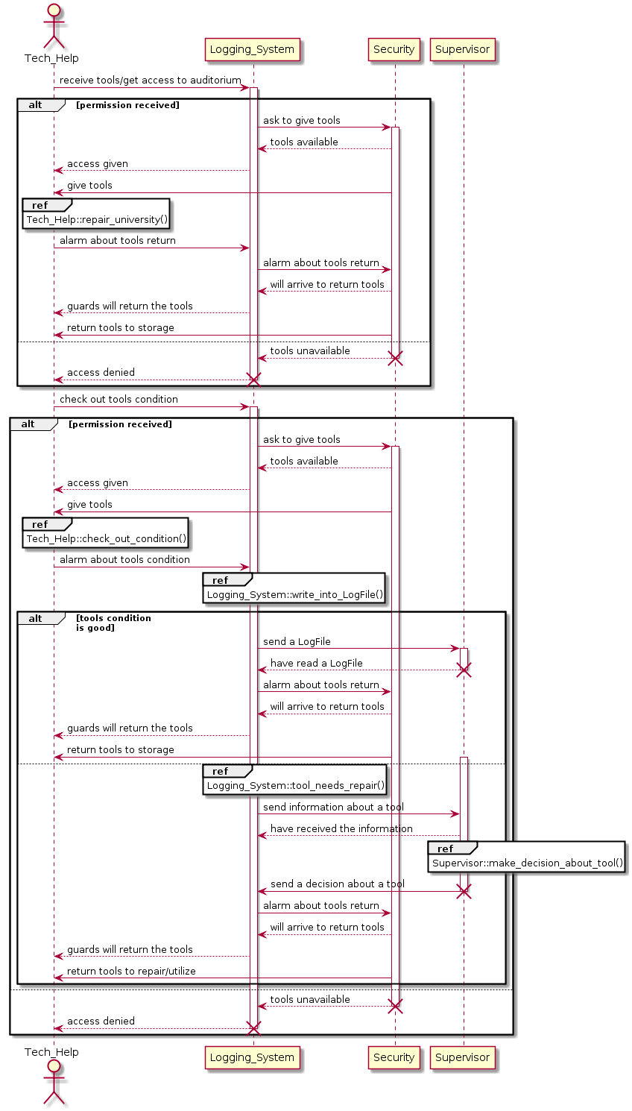@enduml

3.3.12